USER MANUAL
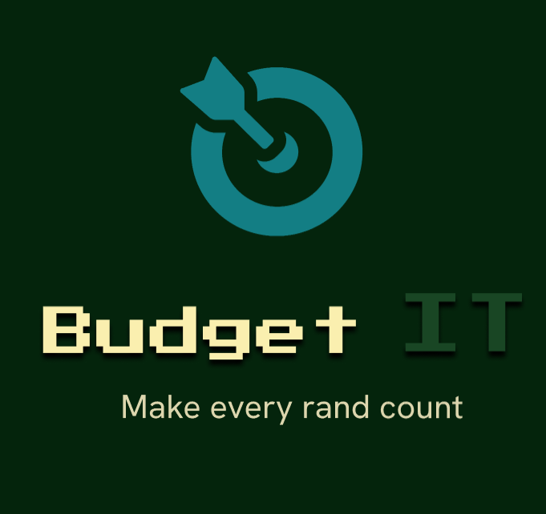

by Dev OOPs

Version 1.0 | 19 August 2026 Nerf your expenses.

Budget IT is a mobile budgeting application for recording income/expenses, organizing spending into budgets, importing bank statements, and aiming to help you understand your financial activity through reports and insights.
- Getting started
Install the application using our apk link on our landing page [ https://github.com/COS301-SE-2026/Mobile-Budgeting-App/deployments/github-pages]. On first launch, Budget IT opens the account access screen.
Recommended first-use sequence:
  - Open Budget IT.
  - Choose Login, Register, or Continue as Guest.
  - Explore the Dashboard, Transaction Manager, and Budget Manager using the bottom navigation.
  - Add your opening income and recent expenses, or import a supported bank statement.
  - Create category budgets that match the way you plan to spend.
  - Return to the Dashboard and reports after entering enough data to see useful trends.
- Account access
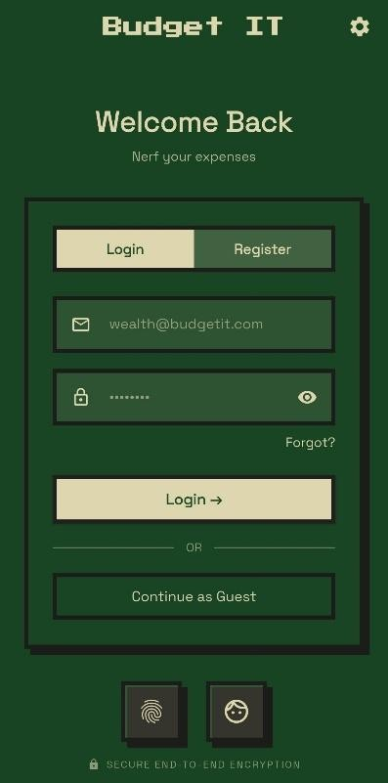
Register
  - Open the Register tab.
  - Enter your email address.

  - Enter a password of at least eight characters and confirm it.
  - Tap Register.
  - Enter the six-digit verification code sent to your email address.
  - Return to Login and sign in. Log in
- Open the Login tab.
- Enter your email address and password.
- Tap Login.
Reset a forgotten password
- Tap Forgot? on the Login tab.
- Enter your email address and request a reset code.
- Enter the six-digit code.
- Choose and confirm a new password.
- Return to Login and use the new password. Continue as Guest
Tap Continue as Guest to open the app without completing authentication.

- Navigate the app
Top Bar


Control | Purpose
Question mark | Open the Help Menu.
Sun or moon | Switch between light and dark mode.
Person | Open the Profile page.
Settings | Open the Settings page.

Bottom Navbar


Control | Purpose
Home | Open the Dashboard.
Money | Open Transaction Manager.
Pie chart | Open Budget Manager.

- Understand the Dashboard
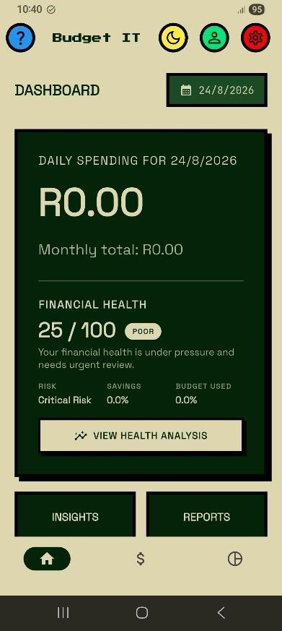
To use the Dashboard:
  - Tap the Home icon.
  - Review the balance and summary cards.
  - Scroll down to inspect trends, insights, and recent transactions.
  - Tap an available report or insight action to open its detail screen.
Note : The Dashboard provides a quick view of your financial position. Its content becomes more useful as you record more transactions.

Dashboard information includes:
    - Current balance based on recorded income and expenses.
    - Quick statistics and spending summaries.
    - Monthly spending trends.
    - Financial insights and a financial health score.
    - Predictive spending information when enough history is available.
    - Recent transactions.
Not enough data? Some predictions and trends require a transaction history. Add or import transactions and revisit the Dashboard later.

- Manage transactions
Open Transaction Manager by tapping the money icon.
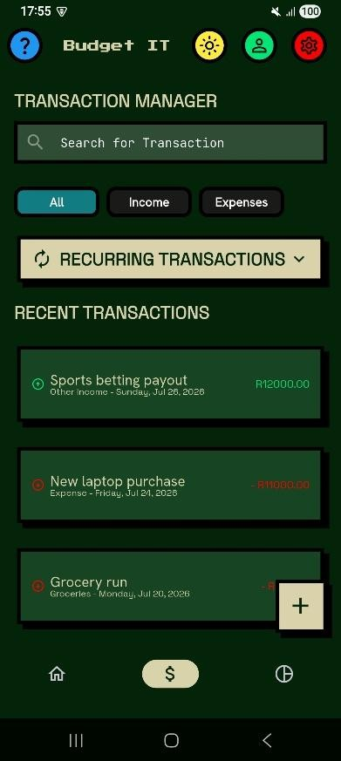

Add a transaction
  - Tap the plus button at the bottom of Transaction Manager.
  - Choose Add Transaction.
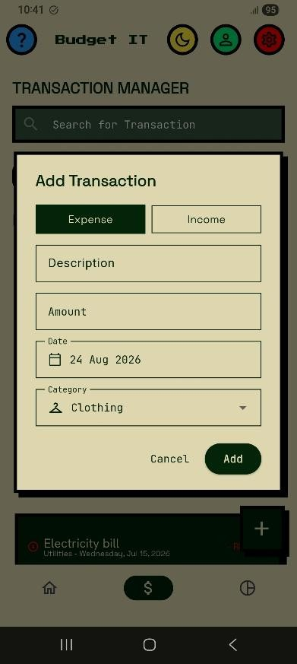
  - Enter a description and amount.
  - Choose Income or Expense.
  - Select the date and category.
  - Tap Add to save.

Field | What to enter
Description | A recognisable name such as Salary, Rent, or Groceries.
Amount | The transaction value.
Type | Income or expense.
Date | The date on which the transaction occurred.
Category | The category used for budgets and reports.

Type part of a description into Search for Transaction. Clear the search field to restore the full list.
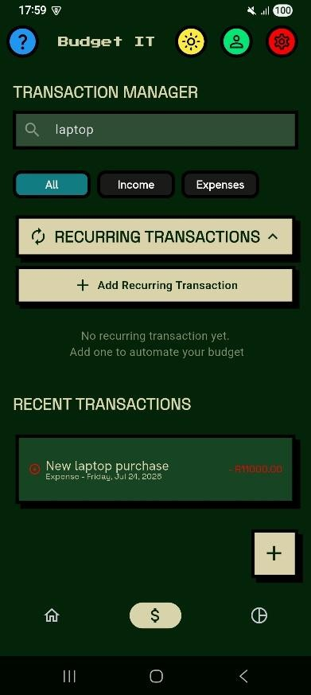
To Edit or delete a transaction:
- Select the transaction you want to change.
- Update its available details and save.
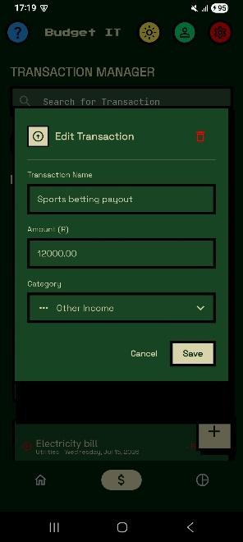

- To remove it, click the red coloured dustbin icon and confirm the prompt.
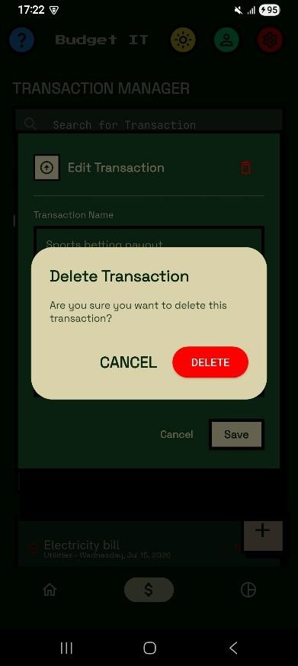

NOTE : Expense transactions assigned to a budget category contribute to that budget's spent amount and report totals.

- Recurring transactions
Recurring transactions are templates for entries that repeat on a schedule.
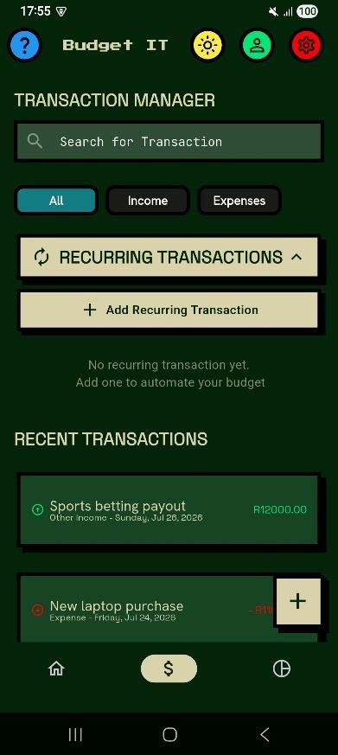
Create a recurring transaction
  - Open Transaction Manager and expand the recurring transactions area.
  - Choose the option to add a recurring transaction.
  - Enter the description, amount, type, category, start date, and recurrence information requested by the form.
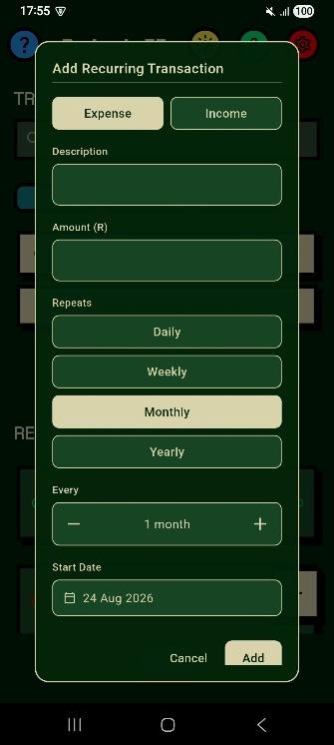

  - Save the recurring transaction.
Note: You can edit a recurring template when its amount, category, or schedule changes, or delete it when it is no longer needed. When Budget IT starts, it checks for due recurring transactions and creates required occurrences. Review Transaction Manager after startup to confirm that expected entries were added.

- Import a bank statement
Budget IT can read supported PDF and CSV statement files and present detected transactions for review.
  - Open Transaction Manager and tap the plus button.
  - Choose Import PDF/CSV.
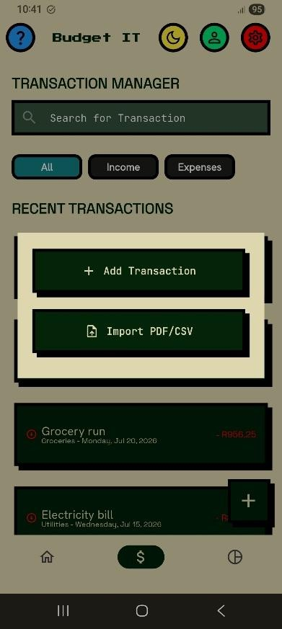
  - On Import Statement, tap Upload a statement and select a supported file.
  - Wait while Budget IT reads and classifies the entries.
  - On Review transactions, inspect New Transactions and Possible Duplicates.
  - Choose whether each entry should be included and correct categories where the interface allows.
  - Tap Import to save selected new transactions.
  - Tap Done on the results summary.

Prevent duplicates: Compare Possible Duplicates with existing transactions and exclude entries that should not be imported twice.

- Create and manage budgets
Budget Manager organises planned expense limits by category and period.
Create a budget
  - Tap the pie chart icon on the bottom navbar.
  - Tap the create a new budget button.

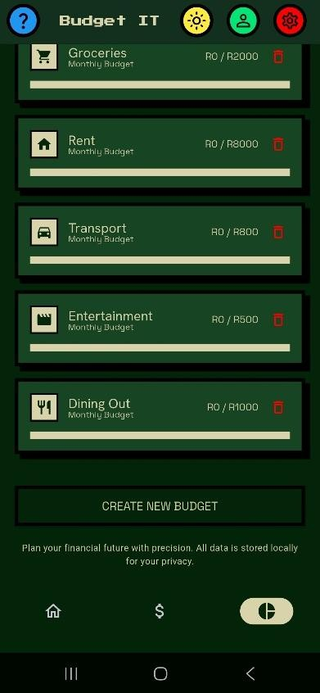

  - Choose the expense category requested by the form and enter the budget limit and click create to save the budget.
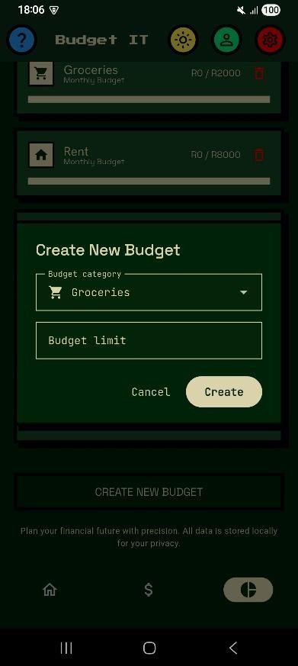

- Monitor a budget
Each card shows its category and progress. Open a card to compare the limit, amount spent, and amount remaining.

Value | Meaning
Budget limit | The maximum amount planned for the selected period.
Spent | Qualifying expenses recorded against the category.
Remaining | The limit minus the amount spent.
Progress | A visual indication of how much of the limit has been used.

Add spending directly to a budget
  - Open Budget Manager.
  - Tap the required category.
  - Under Quick Actions, tap Add Transaction.
  - Enter the transaction details and save.
Use the budget detail actions to edit a limit or delete a budget that is no longer required.

- Reports and exports
To view graphical reports:
  - On dashboard page, tap Reports button.
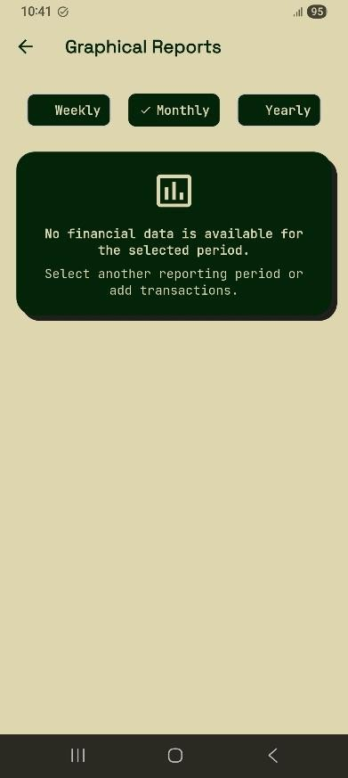
  - Use Weekly, Monthly, or Yearly to change the reporting period.
  - Where available, move between periods or select a year. Scroll through income, expense, category, budget, and spending-trend cards.
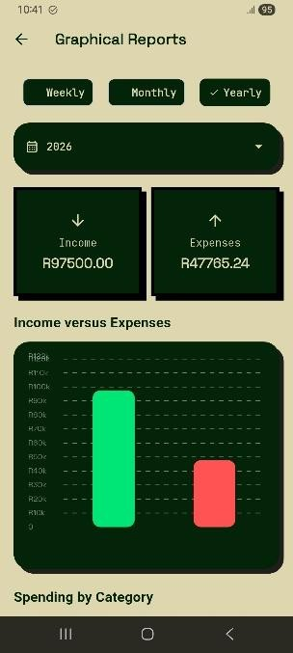

To export financial reports:
- On the budget manager page, click the download button icon indicated by a down arrow on the right.
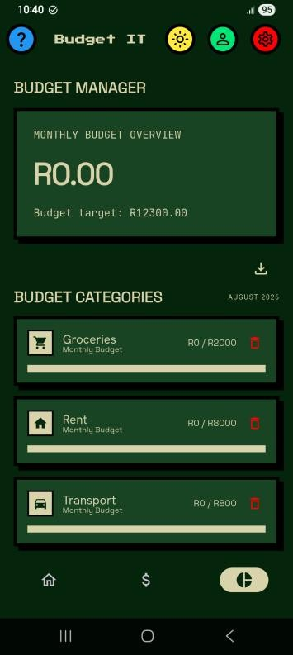
- Choose Export as PDF or Export as CSV. Wait for the completion message and use your device's file handling options to locate or share the export.
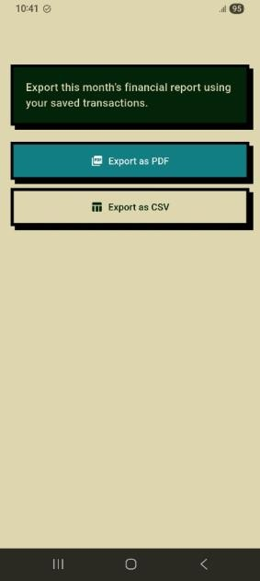
Note: Reports summarize the information you entered. Check transaction dates, types, and categories if a total looks unexpected.

- Insights and predictive spending
Budget IT analyses transaction history to present patterns, projected spending, anomalies, and financial health information.
  - Read insight cards on the Dashboard for notable patterns.
  - Click insights card on the dashboard page to view spending insights.
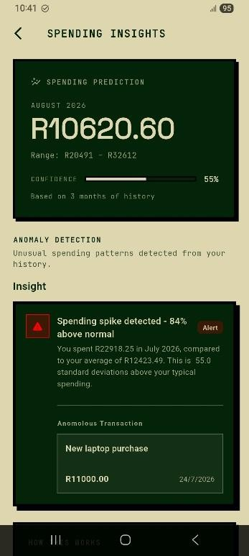
  - Use the financial health score and suggestions as general guidance rather than financial advice.
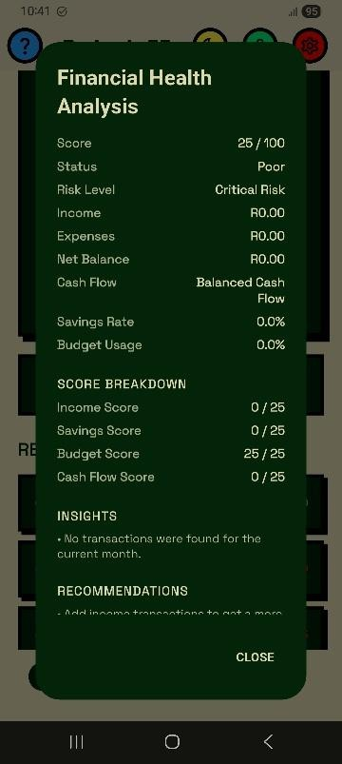

Important: Budget IT supports personal tracking and planning. It does not replace professional financial, tax, or legal advice.

- Switch the theme
Tap the sun or moon yellow icon. The app changes between light and dark mode immediately.
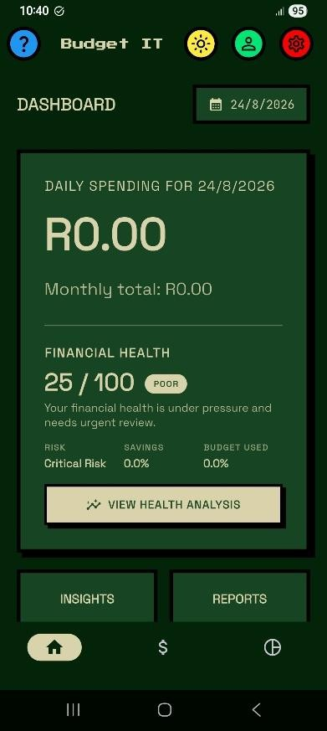

Dark mode Light mode

- Help Menu
Tap the blue question mark icon. Expand a Quick Help item for instructions on adding a transaction, adding one to a budget, or viewing graphical reports.
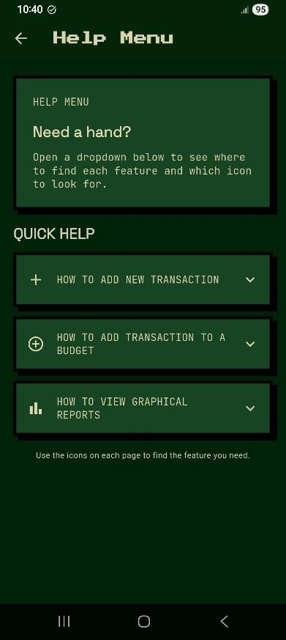

- Privacy, data, and safe use
The app indicates that predictive analysis data stays on your device. Authentication is provided through the configured account service in authenticated builds.
Good practices:
  - Protect your device with a passcode or a biometric lock.
  - Use a unique password for your Budget IT account.
  - Review imported entries before saving.
  - Store exported PDF and CSV reports securely.
  - Check transaction and budget totals regularly.

- Troubleshooting

Problem | What to try
Cannot register | Complete all fields and use matching passwords of at least  eight characters.
Verification code fails | Enter all six digits, use the newest code, or request another  code.
Cannot log in | Check your details, complete verification, or use Forgot?.
Transaction is missing | Clear search, check its date, and confirm that add/import  completed.
Budget total looks  wrong | Check transaction category, amount, type, and date.
Import shows  duplicates | Compare them with existing records and exclude repeated  entries.
Reports are empty | Add transactions and select a period that includes their dates.
Prediction is unavailable | More history may be required; continue using the app and  retry later.
Export fails | Retry and check device storage and file permissions.
Settings cannot be  changed | Settings are still under development in the current build.

Budget IT Developed By Dev OOP’s.

